

**LOAD BALANCING TEST**

### **PREPARED FOR**

Netgear

### **PREPARED BY**

Candela India Pvt Ltd

March 07, 2021

### **Netgear Scripting Project**

**EXECUTIVE SUMMARY**

The Load Balancing Test is designed to check the load balancing feature of the Netgear AP. This feature uses three major tabs to test first is based on Maximum Number of Clients, second is based on Channel Load and third one based on Client Receive Signal Strength, based on which the automated script is designed.

The LOAD BALANCING Test script is basically designed to test and make sure that the AP is able to successfully admit or not admit clients based on certain user set thresholds as RSSI Threshold, Channel Utilization Threshold and Max Client Threshold and will provide clear PASS/FAIL results as the test is finished.

l

| **Netgear Scripting Project:** |  |
| --- | --- |
|  | [07-03-2021]] |

# **1. Project Overview**

The LOAD BALANCING Test is designed to test the Performance of the Netgear Access Point.The goal of this test is to make sure that the AP is able to successfully admit or not admit clients based on certain user set thresholds as RSSI Threshold, Channel Utilization Threshold and Max Client Threshold

# **2. Test Plan**

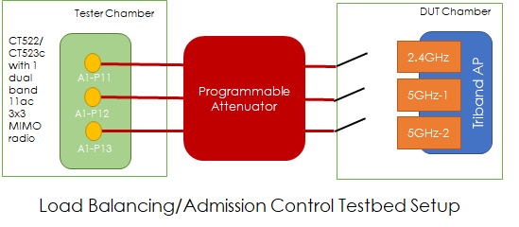

1. Setup testbed as shown above.
2. Set the AP on fixed channels (6, 36 and 161 respectively) for the 3 radios.
3. Start test with LANforge radio programmed to channel 6. Run the three load balancing test scenarios as per test procedure and manually check that the results are correct.
4. For the manual testing part, manually set different RSSI, Channel Utilization and Client count thresholds on the AP and make sure the reported PASS/FAIL results from the test script are accurate.
5. Repeat manual testing for channel 36 and 161.

# **3. How to use Script ?**

1- go to path - home/lanforge/CandelaAutomationScripts/load-balancing/ and run the script from here.

1. If lf_load..py is not present in load balancing you need to copy the file to the

Directory - vim lf_load.py

~paste the code

~ then save and exit

1. If load _template.py not present in load balancing you need to copy load_template.py there for report generation - follow same as above
2. These are the tabs available for load balancing in Netgear AP

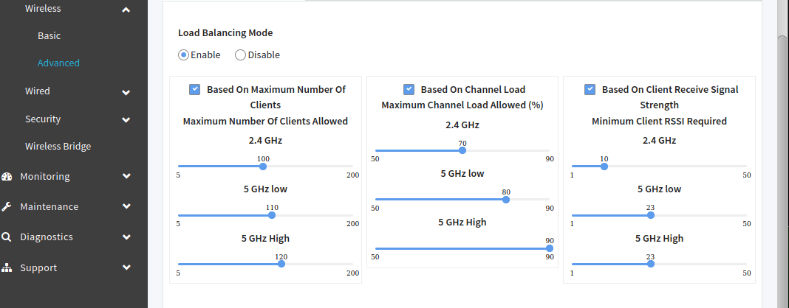

1. Cli to execute the python test eg -

~ **python3 lf_load.py --ip 192.168.208.196 --user root --pswd Password@123xzsawq@! --host localhost --ssid loadbalance --passwd [BLANK] --security open --radio wiphy3 --test Rssi --bands 5G_low --client 20 --client5 30 --client5h 35 --ch_threshold 90 --ch_threshold5 80 --ch_threshold5h 90--rssi2 18 --rssi5l 10 --rssi5h 10**

Here

**--ip -** AP ip

**--user** - AP webpage login/username

**--pswd -** AP webpage password

**--host** - LANforge ip address but if you are running script inside lanforge use “localhost”

**--ssid** - ssid for clients

**--passwd** - password to connect to ssid if open security use [BLANK]

**--security** - security type used by ssid default open

**--radio** - radio at which client will be connected default wiphy3

**--upstream** - provide upstream name like eth1/eth2 by default eth1 is used

**--num_sta -** provide number of stations you want to create

**--test** - select type of test you want to perform like

For Max client test use - Client

For Channel Utilization use - Utilization

For Rssi based test use - Rssi

By default all three test will be - Client Utilization Rssi

**--bands** - select the type of band on which you want to perform test like

For 2.4 ghz use - 2.4G

For 5 ghz low use - 5G_low

For 5 ghz high use - 5G_high

**--client** - option to set Threshold value for 2.4 GHz for Maximum number of client test

**--client5** - option to set Threshold value for 5 ghz low Maximum number of client test

**--client5h** - option to set Threshold value for 5 ghz high Maximum number of client test

**--ch_threshold** - option to set Threshold value for 2.4 ghz for Channel load

**--ch_threshold5** - option to set Threshold value for 5 ghz low for Channel load

**--ch_threshold5h** - option to set Threshold value for 5 ghz high for Channel load

**--rssi2** - option to set Threshold value for 2.4Ghz for Rssi test

**--rssi5l** -option to set Threshold value for 5 Ghz low for Rssi test

**--rssi5h** - option to set Threshold value for 5 Ghz high for Rssi test

1. After execution of script results can be seen on the html-reports directory

`~ /home/lanforge/html-reports

Log files can be seen in loadbalancelog folder

Pdf report and html reports can be found inside loadbalancing folder as per execution date

# **4. Results**

Screenshot of pdf report generation is shown below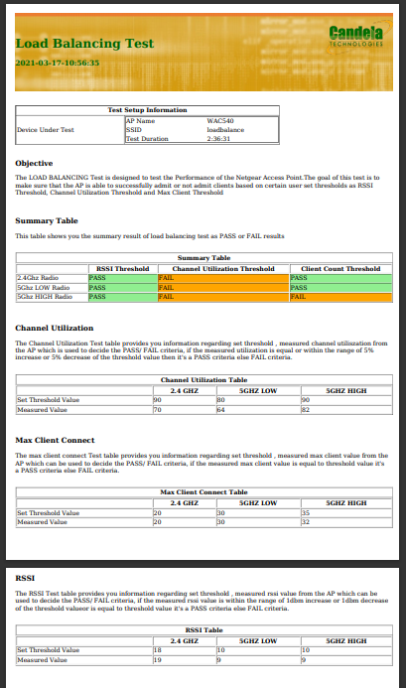

# **5. Contact**

Visit - <https://www.candelatech.com/>

For any support related help contact - [support@candelatech.com](mailto:support@candelatech.com)